Virtual LAN (VLAN) Configuration and Management
This project demonstrates how to configure Virtual LANs (VLANs) to divide a network into smaller logical groups. The network is created and tested using Cisco Packet Tracer. Different PCs are placed in different VLANs, and a router enables communication between them using inter-VLAN routing.

Name:-Afreen Akram Shaikh
Subject:-Cloud Computing
Institution:-Anudeep Foundation
Year:-2026

1. Introduction
A Virtual Local Area Network (VLAN) is a networking technology that allows a physical network to be divided into multiple logical networks. VLANs help group devices based on their function, department, or project instead of their physical location. This improves network organization, performance, and security.
In traditional networks, all devices connected to the same switch belong to the same broadcast domain. This can cause network congestion and security risks. VLANs solve this problem by creating separate broadcast domains within the same switch.
In this project, VLANs are configured and managed using Cisco Packet Tracer, which is a network simulation tool used to design, configure, and test networks in a virtual environment.

2. Objectives
The main objectives of this project are:
- To understand the concept and importance of VLANs in networking.
- To create and configure VLANs on a network switch.
- To assign switch ports to different VLANs.
- To configure trunk ports for VLAN communication.
- To implement inter-VLAN routing using a router.
- To test and verify network connectivity.

3. Tools and Software Used
The following tools were used in this project:
- Cisco Packet Tracer – Used for network simulation and configuration.
- Computer or laptop.
- Networking devices such as router, switch, and PCs (simulated in Packet Tracer).

4. Network Topology
Network topology refers to the arrangement or layout of devices in a computer network. It shows how devices such as computers, switches, and routers are connected and how data flows between them. In this project, the network topology is created using Cisco Packet Tracer to connect PCs, a switch, and a router for VLAN configuration.
The network topology used in this project includes the following devices:
- 1 Router
- 1 Switch
- 3 Personal Computers
Connections:
- PC0 connected to Switch port Fa0/1
- PC1 connected to Switch port Fa0/2
- PC2 connected to Switch port Fa0/3
- Switch connected to Router through Fa0/24 to G0/0
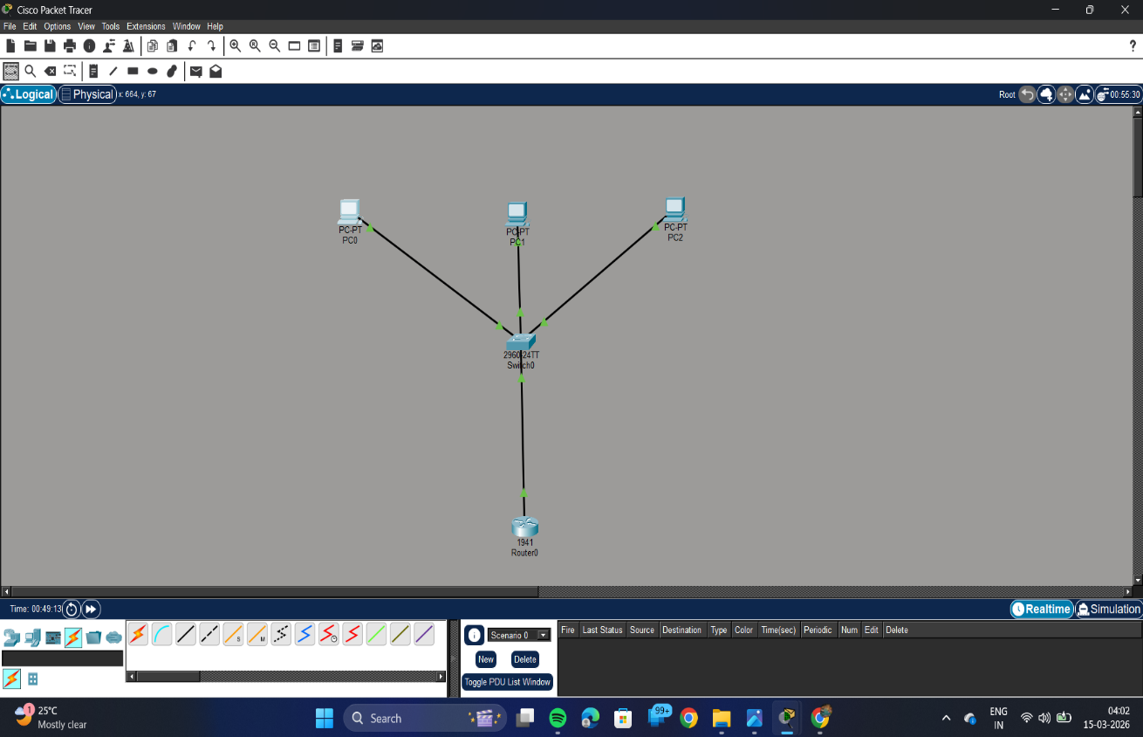
- Each PC is placed in a separate VLAN.
5. VLAN Configuration
Three VLANs were created on the switch to divide the network into different logical groups.
VLAN ID | VLAN Name
10 | SALES
20 | HR
30 | IT

Ports were assigned to VLANs as follows:
Switch Port | VLAN
Fa0/1 | VLAN 10
Fa0/2 | VLAN 20
Fa0/3 | VLAN 30
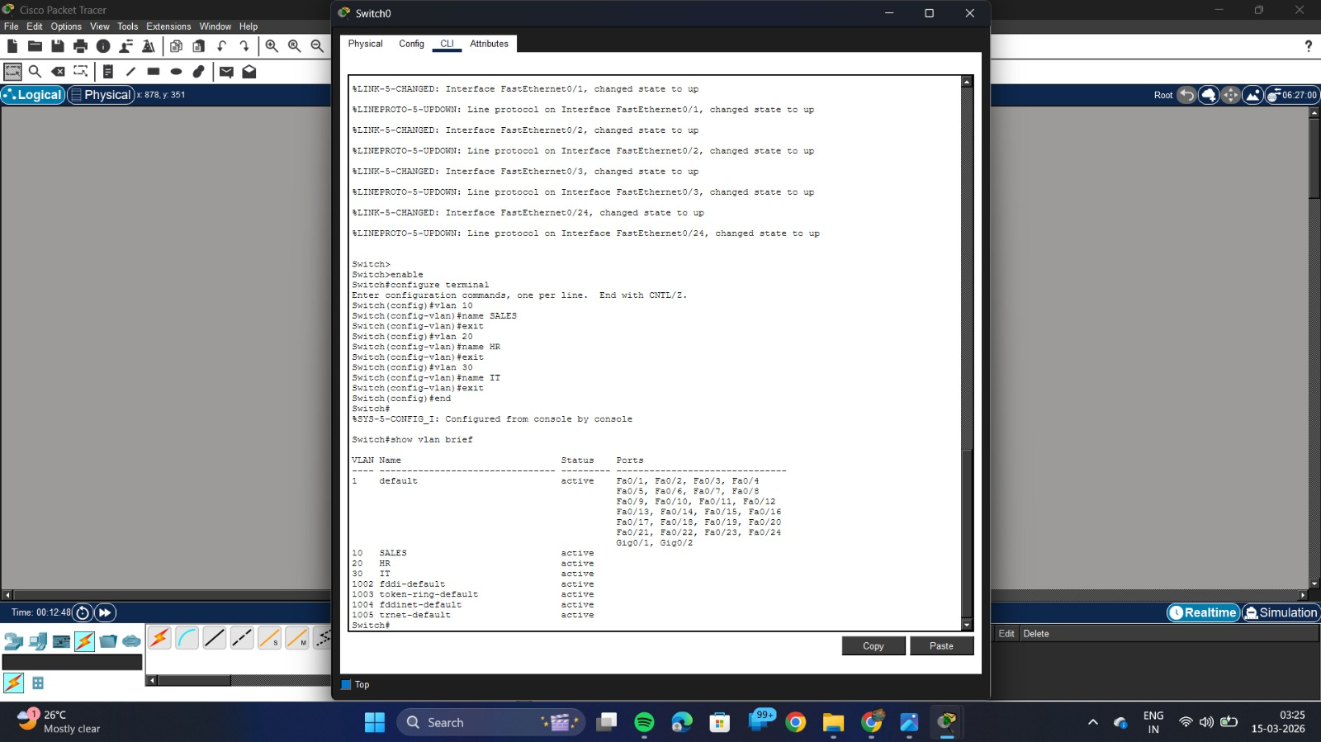

6. Trunk Configuration
A trunk port was configured between the switch and router to allow multiple VLAN traffic to pass through a single connection.
Port Fa0/24 on the switch was configured as a trunk port.
This allows VLAN 10, VLAN 20, and VLAN 30 traffic to travel between the switch and the router.
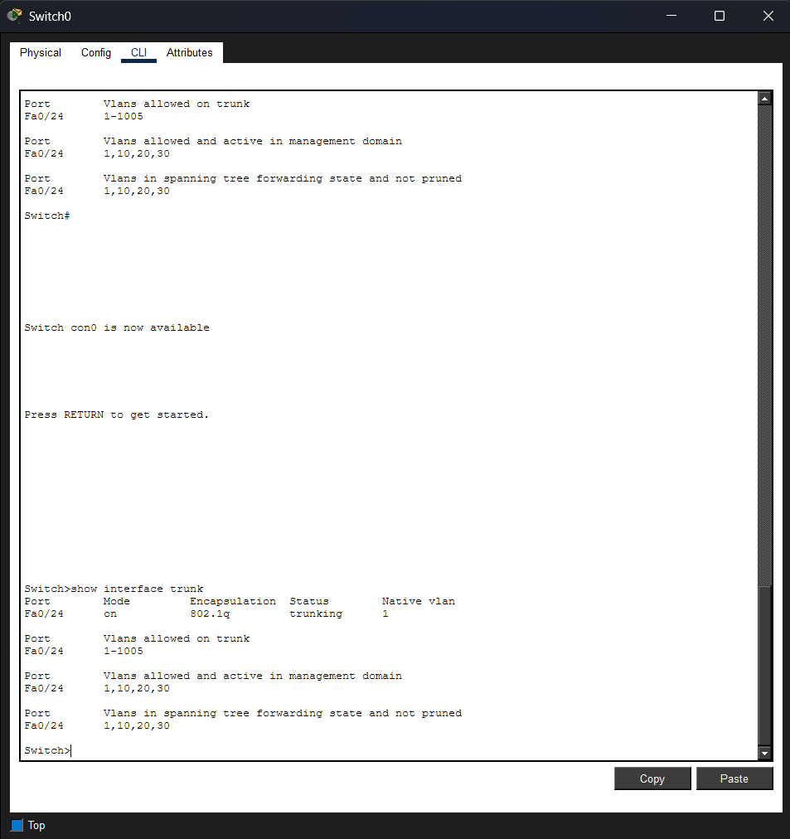
7. Router Configuration
Inter-VLAN routing was implemented using the Router-on-a-Stick technique.
Subinterfaces were created on the router for each VLAN with unique IP addresses.

Router Interface | IP Address
G0/0.10 | 192.168.10.1
G0/0.20 | 192.168.20.1
G0/0.30 | 192.168.30.1

Each IP address acts as the default gateway for its VLAN.
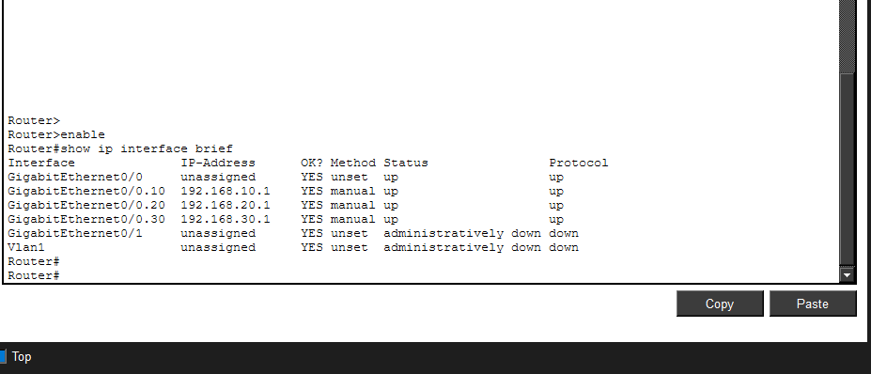

8. IP Address Configuration
Each PC was assigned an IP address and default gateway.
Default Gateway

Device | IP Address | DefaultGateway
PC0 | 192.168.10.2 | 192.168.10.1
PC1 | 192.168.20.2 | 192.168.20.1
PC2 | 192.168.30.2 | 192.168.30.1

9. Testing and Verification
The network connectivity was tested using the ping command from the command prompt.
Example commands used:
ping 192.168.20.2
ping 192.168.30.2
Successful replies confirmed that devices in different VLANs can communicate with each other through the router.
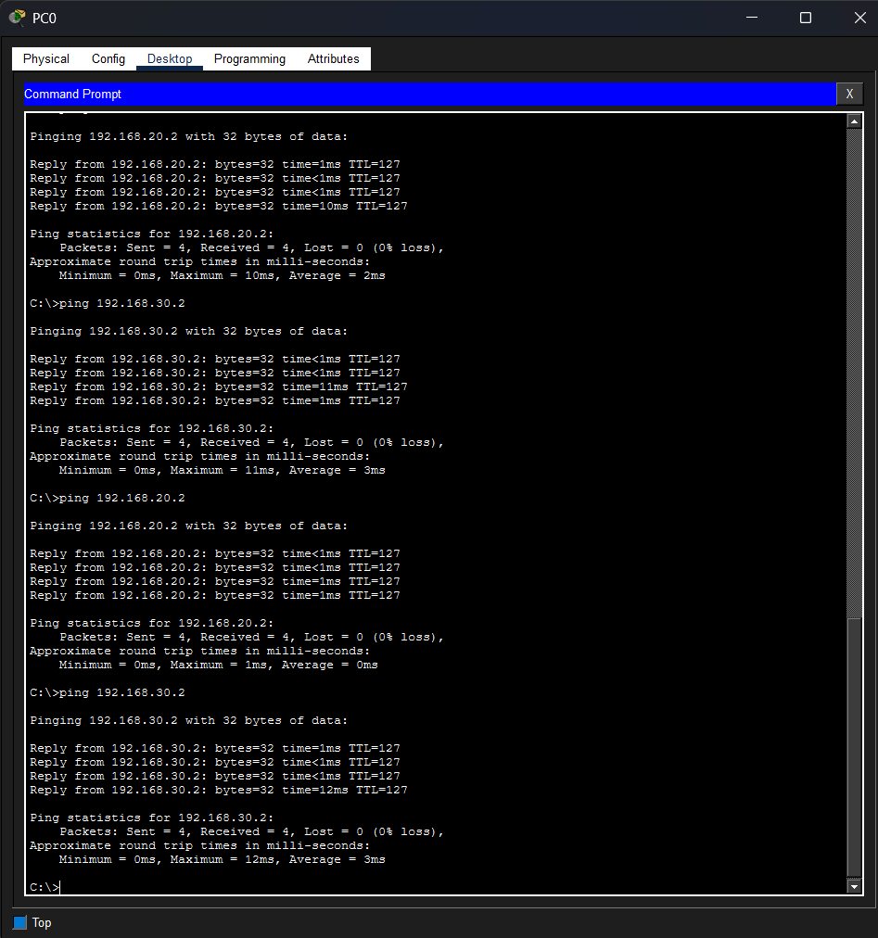

10. Results
The VLAN configuration was successfully implemented. Devices from different VLANs were able to communicate with each other through inter-VLAN routing. The network segmentation improved organization and control of the network.

11.Conclusion
This project demonstrates the configuration and management of VLANs in a network environment. VLANs help improve network performance, security, and management by logically separating devices into different networks. Using Router-on-a-Stick, communication between VLANs was successfully established.

